**Logical reasoning (set 2)**

**Company name: oracle No. of Question: 10**

**1:** Find the missing term in the given series?

54 52 50 47 45 43 40 ? ?

1. 37 35
2. 36 34
3. 38 36
4. 38 35

**Answer:** option c

**Solution:**

This is an alternating subtraction series in which 2 is subtracted twice, then 3 is subtracted once, then 2 is subtracted twice, and so on.

**2:** Identify the symbols to be inserted to make the expression correct.

80 * 4 * 8 * 2 * 4

1. =, +, ÷, ×
2. ÷, =, ×, +
3. ÷, ×, +, =
4. +, =, ×, ÷

**Answer:** option b

**Solution:**

80 ÷ 4 = 8 × 2 + 4

**3:** DIRECTION: Which figure from the given options can replace the question mark?

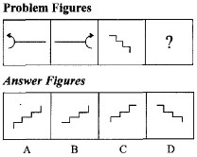

1. A
2. B
3. C
4. D

**Answer:** option c

**Solution:**

Second figure is the mirror image of first figure.

**4:**There are two sets of figures namely problem Figure containing five figures 1, 2, 3, 4, 5 and answer figures (a), (b), (c), (d). You have to select one Figure from the answer set which will continue the same series as given in problem set figures.

Problem figure

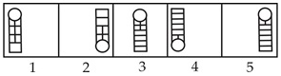

Answer figure

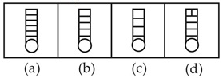

1. (a)
2. (b)
3. (c)
4. (d)

**Answer:** option a

**Solution:**

Problem figure 2 is reverse of figure 1 with same number of horizontal lines and vertical lines decreases by one row. Similarly, Figure 4 is revers of figure 3 and symmetrical changes in pattern of lines. Therefore, answer figure (a) is reverse of problem figure 5.

**5:**What comes in place of?

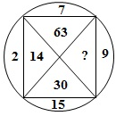

1. 18
2. 33
3. 135
4. 145

**Answer:** option c

**Solution:**

We have 15 × 2 = 30, 2 × 7 = 14, 7 × 9 = 63

So missing number = 9 × 15 = 135

**6:**Count the number of squares in the given figure?

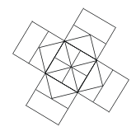

1. 22
2. 20
3. 18
4. 14

**Answer:** option c

**Solution:**

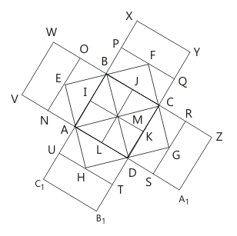

The squares composed of two components each are BJMI, CKMJ, DLMK and AIML i.e. 4 in number.

The squares composed of three components each are EBMA, BFCM, MCGD and AMDH i.e. 4 in number.

The squares composed of four components each are VWBA, XYCB, ZA1DC and B1C1AD i.e. 4 in number.

The squares composed of seven components each are NOJL, PQKI, RSLJ and TULK i.e. 4 in number.

There is only one square i.e. ABCD composed of eight components.

There is only one square i.e. EFGH composed of twelve components.

∴ Total number of squares in the figure = 4 + 4 + 4 + 4 + 1 + 1 = 18.

**7:**Find out the alternative figure which contains figure (X) as its part?

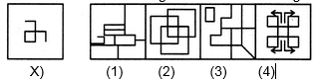

1. 1
2. 2
3. 3
4. 4

**Answer:** option b

**Solution:**

https://www.indiabix.com/_files/images/non-verbal-reasoning/embedded-images/42-1.png

**8:**How many points will be on the face opposite to in face which contains 2 points?  
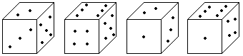

1. 1
2. 5
3. 4
4. 6

**Answer:** option d

**Solution:**

The face opposite to 2 will be 6.

**9:**DIRECTIONS: Solve the alphanumeric series given below:

A1B, E5F, I9J, O15P, ?

1. U9V
2. U21V
3. U13V
4. U15V

**Answer:** option b

**Solution:**

A, E, I, O, U

1, 5, 9, 15, 21

A⟶B, E⟶F, I⟶J, O⟶P, U⟶V,

A1B, E5F, I9J, O15P, U21V

**10:**DIRECTIONS: Choose the odd one out from the given alternatives.

1. 836432
2. 836654
3. 836986
4. 836475

**Answer:** option d

**Solution:**

Except option (4) in all other options the sequence of numbers after 836 is in decreasing order.